***A Mini Project Synopsis on***

**ONLINE BOOK STORE**

**S.E. - I.T Engineering**

**Submitted By**

**VATSAL SINGH 19104006**

**SHUBHANGI TRIPATHI 18104067**

**PUSHKAR TELAVANE 19104011**

**SOURAV JOSHI 19104068**

**Under The Guidance Of**

**PROF. ANAGHA AHER**



**DEPARTMENT OF INFORMATION TECHNOLOGY**

A. P. SHAH INSTITUTE OF TECHNOLOGY

G.B. Road, Kasarvadavali, Thane (W), Mumbai-400615

UNIVERSITY OF MUMBAI

**Academic year: 2020-21**

**CERTIFICATE**

This to certify that the Mini Project report on **ONLINE BOOK STORE**

has been submitted by **VATSAL SINGH (19104006), SHUBHANGI TRIPATHI (18104067),PUSHKAR TELAVANE (19104011) and SOURAV JOSHI (19104068)** who

are a Bonafide students of A. P. Shah Institute of Technology, Thane, Mumbai, as a

partial fulfilment of the requirement for the degree in **Information Technology**, during

the academic year **2020-2021** in the satisfactory manner as per the curriculum laid down

by University of Mumbai.

Prof. Anagha Aher

Guide

Prof. Kiran Deshpande Dr. Uttam D. Kolekar

Head Department of Information Technology Principal

External Examiner(s)

1.

2.

Place: A. P. Shah Institute of Technology, Thane.

Date:

**TABLE OF CONTENTS**

1. Introduction..........................................................................................................
   1. Purpose......................................................................................................
   2. Objectives....................................................................................................
   3. Scope..............................................................................................................
2. Problem Definition…………………...................................................................
3. Proposed System………......................................................................................
   1. Features and Functionality………………...……………………………….
4. Project Outcomes..................................................................................................
5. Software Requirements ........................................................................................
6. Project Design.......................................................................................................
7. Conclusion............................................................................................................

References

Acknowledgement

* **INTRODUCTION**

The Online Book Store has been developed to override the problems prevailing in the practicing of manual system. This website is supported to eliminate and, in some cases, reduce the hardships faced by existing system. Moreover, this system is designed for need of the company to carry out operations in a smooth and effective manner.

The application is reduced as much as possible to avoid errors. No formal knowledge is required by the user to use this system. Thus, by all views it provided user friendly environment. It is secure, reliable and fast management. User will be able to buy books across the world without any constraint of time and location.

 Online Book store is an online web application where the customer can purchase books online. Through a web browser the customers can search for a book by its title or author, later can add to the shopping cart and finally purchase the books.

Online Book Shopping is the norm these days. There are lot of successful websites such as amazon.com, flipkart.com etc. in this space. Purpose of Online Book Shopping system is to allow customer to shop virtually using internet. Computerization of online store will increase the ease, efficiency and reduce the chances of manual errors. With the popularity of PCs, and mobiles easy access to Internet and World Wide Web (WWW), Internet is increasingly used by consumers & vendors as a channel for shopping, payment & other operations

* **Purpose:**

The Online bookstore is capable to selling books online across the world. The base purpose of our project is to develop a system that empowers selling of books of different variety to user in a fast and comfortable way. This project aims to automate the existing manual system by the help of Python language fulfilling requirements. “Online Book Store” is to provide an essence of online bookstore via a simple and yet powerful medium. The project has been designed to simulate the working of an actual online bookstore.

The main aim is to automate its existing manual system by help of computerized equipment and full-fledged computer software. Basically, our project aims to describe management for good and better services for the clients.

It will automate some of the basic operations of an online store. Scope would be to provide basic functionalities using a web application so that those manual process can be automated. It will include to provide administration access to vendors and admins and user specific access to customers.

* **Objective**:
* The Online Book Store Project provides customers with online shopping facility through a web browser. A customer can search for his /her required book and then make payment for the same to buy them. The Administrator will have additional functionality when compared to the common user. He can add, delete, and update the author, publisher, book categories, book details, member information and confirm a placed order.
* Provides searching facility- user should be able to search for book using book id
* Easy to make payments for books.
* Shows information and description of book.
* Editing, updating adding, deleting book- Admin will be able to keep up to date with books releases and updating.
* Increases efficiency of selling books worldwide- will not be restricted to on area or particular region.
* Have a good user interface
* Be expandable
* Easy operations- user must be able to handle the system easily
* Satisfy user requirements- yield satisfied customer and their experience
* User can put books into a cart

**Advantages**

• Performance: Most of Operations and tasks in underlined system are repetitive and time consuming. Also there are chances of manual errors in the system. So an efficient, effective, fast system is desired. Hence this web based computerized system is undertaken which is very fast and user friendly.

• Ease & Efficiency: The basic need of this website is efficiency and simplicity. This website is efficient as it provides easy browsing & data entry for user. Users can easily view all the related operations along with all relevant details.

• Control: The complete control of the project is under the hands of authorized person. Only customer can access their own account. All control is under the administrator and members have the rights to just see their concerned records and transactions.

• Security: Security is one of the main concerns for any modern application. So, security is the important criteria for the purposed system. Proper authentication and authorization is implemented so that only right person will get right access.

* **Scope:**

It may help collecting perfect management in details. In a very short time, the collection will be obvious, simple and sensible. It will be also reduced the cost of collecting the management and collection procedure will go smoothly.

* To provide users to purchase book online.
* To add/delete user, manage books information and status.
* To reduce user’s searching time.
* To provide great discount over purchasing.
* To provide wide collection of book ranges
* To provide user friendly environment.
* To provide easy payment of books to user.
* In our system it is not necessary to create the manifest but we can directly print it and save time.
* Economic Feasibility:

As this is a very important aspect to be considered while developing a project. We decided the technology based on minimum cost factor. All hardware and software cost has to be borne by organization. Overall, we have estimated the benefits the organization is going to receive from proposed system will surely overcome initial costs and later on running cost of organization.

* **Problem Definition:**

Problem Identified:

To facilitate online book purchase. Design and implement an online bookstore.

* Solution Proposed:

Develop an e-commerce platform using PYTHON to sell books online where required books can be searched and purchased including every aspect i.e., customer, book, money.

The system will ease the shopping operations for customer of online store. It will provide vendor or administration functionality to manage categories and products. Consumer will be able to browse and search products under different categories. Selected products or items selected for purchase would be added into the virtual shopping cart. Which can be managed separately by customer. It can be examined at any time by customer for selected products, their quantity & price. These would be main functionalities apart from some usual operations such as login, logout, manage profile etc

* **Proposed System:**

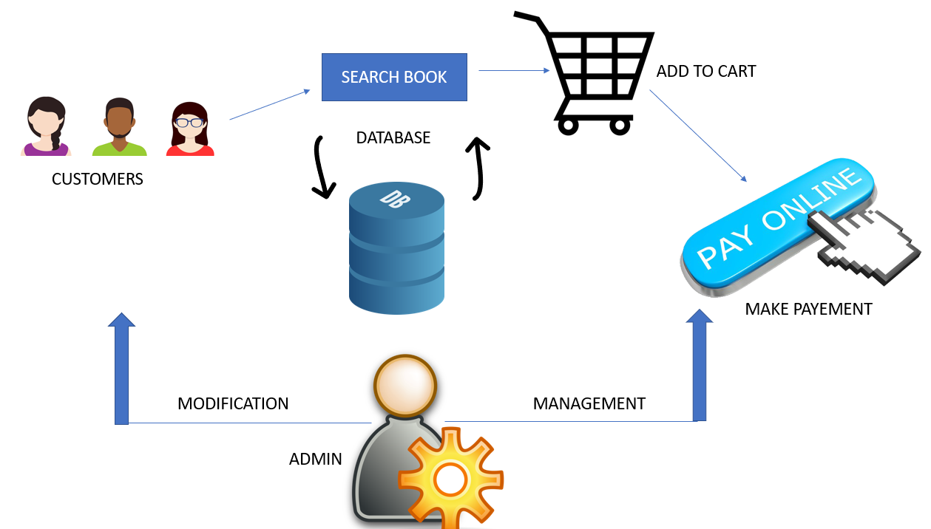

Fig 1- Shows the basic layout of whole system which includes customer and admin module

* As we can see in above diagram, the customer gets to search the book. All the books information will be stored in a database. After choosing the book customer can put them in cart and then proceed to payment through credit or debit card or cash on delivery. All this activity is managed by ADMIN who can modify, add or delete books from the list and also manage the working of whole system.

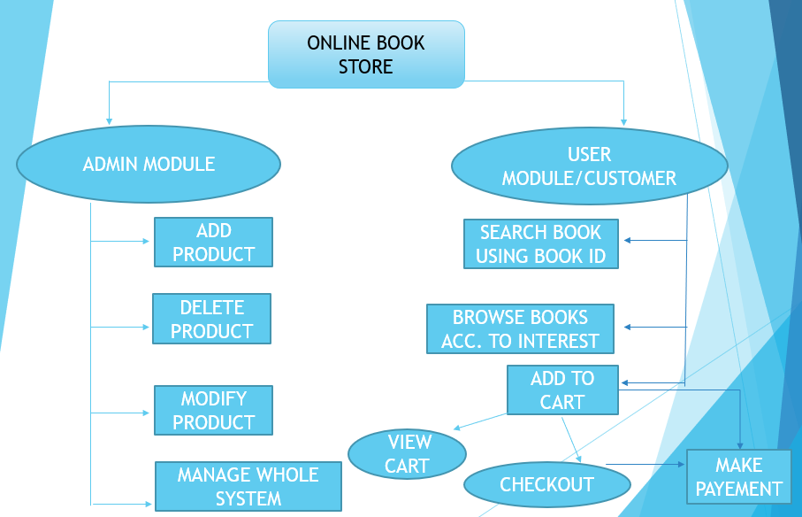

Fig 2- Block diagram of our system which is mainly divided into two modules user and admin.

* Admin module- admin can update, modify, add and delete according to requirement. Customer on the other hand will be able to search for a book using filters like BookID or Author name. after searching customer can put them in their cart and checkout for payment using options given there.
* **Feature and Functionality:**

The features and functions provided in this project should satisfy all the user requirements and should be flexible enough so that future changes can be easily done based on the future upcoming requirements.

* Will give access to wide range of books from anywhere around the globe.
* Online stores are cheap, shopping is convenient, and stores are not limited.
* Payment gateway service that authorizes credit card or direct payments processing.
* Convenient way to buy books.
* Wild range of books available which speed up our decision process.
* Searching becomes easy.
* Wastage of time don’t take place.
* Cost saving due to discounts.
* Global availability
* Benefits to organization- it will be able to gain benefits such as savings in operating cost, reduction in paperwork, better utilization of human resources and more presentable image increasing goodwill.
* Security of data and ensured data accuracy
* Minimal human inclusion with greater efficiency.
* **Project Outcome:**

This project guarantees the ease of book business through online mode. With many functions this project will provide all assured things.

* User can search for required books.
* Used can but books by making payment.
* Gets to search conveniently using book id number
* Admin can update the existing data
* Customers can put books into cart for further purchase
* **Technological requirements:**
* **Software Required**

Hardware required:

* Processor: Intel Core 2 Duo or above
* RAM: 2GB or above

Software to be used:

* Operating System: Windows (XP, Vista or 7)
* Front end - PYTHON
* Back end- SQL
* **Project Design:**

The layout is given below. The final appearance of interface will look like this.

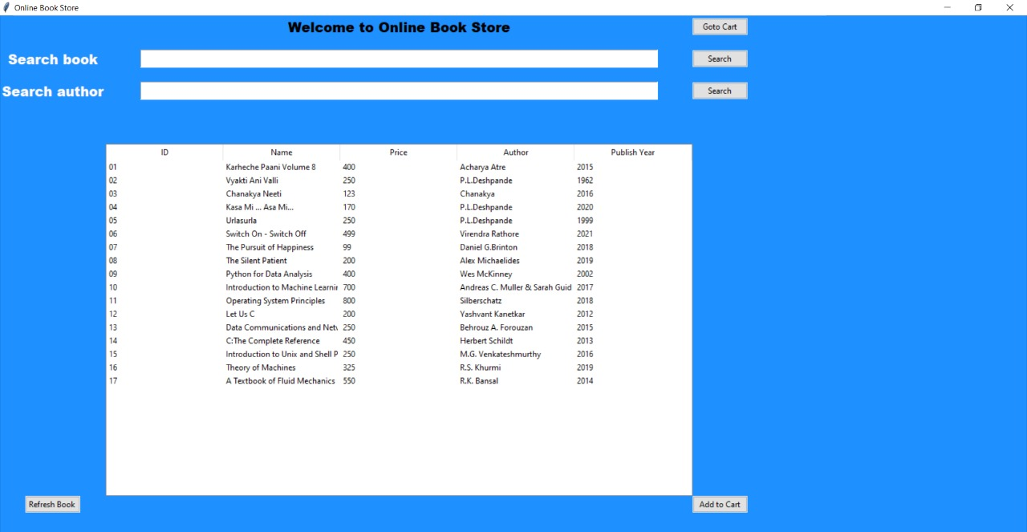

Fig 3- Customer panel. List of books is visible from customer can search.

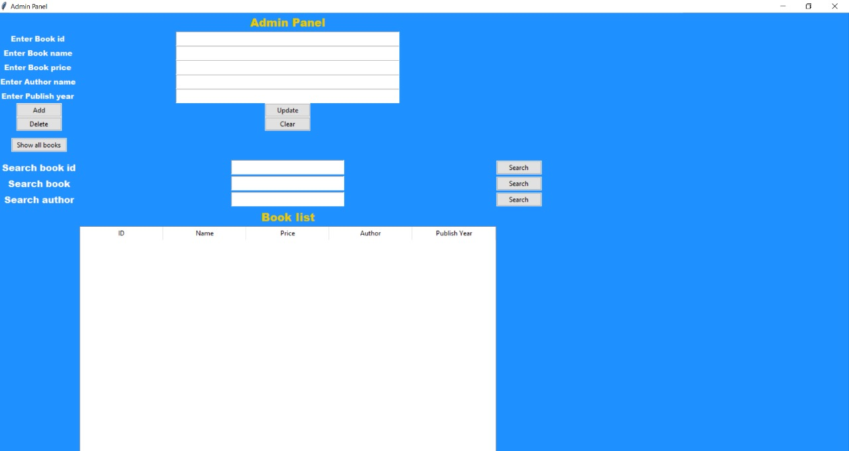

Fig 4- Shows the admin module. Here admin can add and delete books and modify any entry

* **Project Scheduling:**

|  |  |  |  |
| --- | --- | --- | --- |
| **Sr. No** | **Group Member** | **Time duration** | **Work to be done** |
| **1** | Vatsal Singh | 1st week of January | Implement the backend |
| **2** | Shubhangi Tripathi | 2nd week of January | Implement the features like GUI |
| **3** | Pushkar Telavane | 3rd week of January | Implement the basic frame of code in python |
| **4** | Sourav Joshi | By the end of march | Implement the. Overall linking of project |

* **Conclusion:**

The switch from written books being from bookstores to being. Ordered online or even just digital copies has had profound effects on the industry including bookstores and libraries and the general people of the world. The positives include easy access for everyone and cheaper books along with saving natural resources. There will be lot of scope to improve this project, since currently basic functionality would be provided.

Some of the modules to improve are admin part such as personalized recommendations, discount & offer management. For customers, notification & messaging etc. can be improved. These can be developed to make it more effective.

* **References:**
* WIKIPEDIA- <https://en.wikipedia.org/wiki/Online_book>
* YOUTUBE- <https://www.youtube.com/watch?v=FzW4S1qHrIQ>

***ACKNOWLEDGEMENT***

This project would not have come to fruition without the invaluable help of our guide **Prof. Anagha Aher**

Expressing gratitude towards our **HOD, Prof. Kiran Deshpande**, and the Department of Information

Technology for providing us with the opportunity as well as the support required to pursue this project. We

would also like to thank our teacher **Prof. Anagha Aher** who gave us her valuable suggestions and ideas

when we needed them. We would also like to thank our peers for their helpful suggestions.